**BANK LOAN REPORT**

**Aim-** This report aims to provide insight into banks key loan related metrics like Debt-to-Income Ratio (DBT), loan application, funded amount, interest rates. By which we can able to take smarter decision, to know the customer trends to repay, and the behaviour of the customer, by the regular check of the bank portfolio we can able to understand the health of our bank, and will guided over future lending strategies, so it’s helped the organisation to make data driven decision.

Problem Statement- The bad debt is increasing these days, for the better understanding the default regions the bank needs to check its related metrics on which disbursement of loan depend by which we know the customer repay status and bank plan its strategies for future disbursement, it helps us to know the targeted customers who pay on time and which one a defaulter.

Data Visualization-

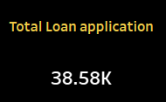

The total number of loan application is received by a bank in present financial year is 38 thousand five hundred eighty.

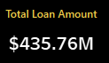

The Total loan amount disbursed to the borrowers is four hundred thirty-five point seven six million dollar.

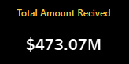

The total amount of fund is disbursed by a bank to its borrowers as a loan, it’s a sum of amount repay by the borrowers.

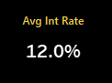

The overall rate in percent on which the bank disburses the loan to it borrowers is twelve percent.

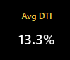

Debt-to income ratio is a rate of percentage which depends on many factors it indicates the customer creditworthiness; DTI is like a civil score. I.e., 13.3 %

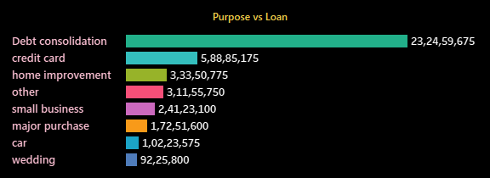

Mostly customers take loan for the purpose to pay debt, 23 crore loan is disbursed to a customer, which is highest in all.

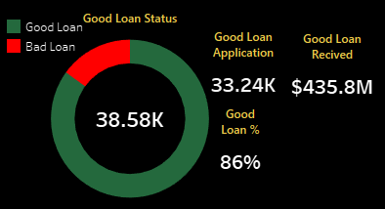

The total loan application is received by the bank is thirty-eight thousand five hundred eighty, which indicates inside the donut chart, out of which 33.24k is the good loan applicants, from good customer the fund received is 435.8 million dollar, the green colour indicates the good loan application percentage i.e., 86% of total loan applications, the red colour indicates the bad loan, good customers are those who pay the payments on time.

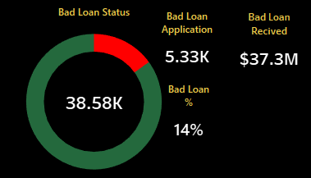

The total loan application is received by the bank is thirty-eight thousand five hundred eighty, which indicates inside the donut chart, out of which 5.33k is the Bad loan applicants, from bad customer the fund received is 37.3 million dollar, the green colour indicates the good loan application percentage i.e., 86% of total loan applications, the red colour indicates the bad loan i.e.,14%, bad customers are those who doesn’t pay the payments on time is also known as the defaulters for the band, so we keep eyes on that customers we take necessary steps to control it.

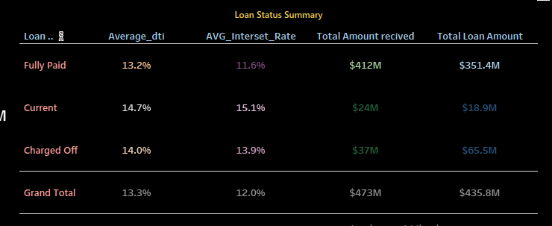

The above chart is explaining the loan status summary, the customer is categorised into fully paid, current, charged off fully paid those who pay full amount of his loan on time, current who pay the payments on time means they both are under good customers, charged off are those who does not pay their dues on time, This table provides insights into the performance and characteristics of loans based on their status, including debt-to-income ratios, interest rates, and financial amounts involved.

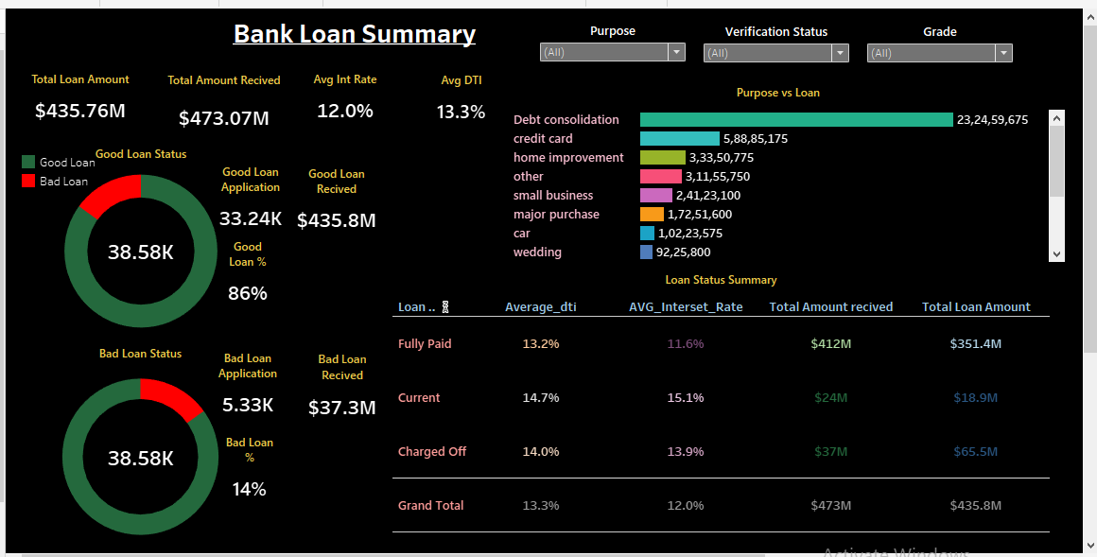

Conclusions –

The majority of the loan portfolio is healthy, with 86% of loans classified as 'Good Loans.'

DTI and interest rate in manageable limit. But the noticeable increment in the Average Debt to income (DTI) and average interest rate for current loan is indicating a higher risk profile.

A debt consolidation contributes a significant or higher portion for the loan portfolio, followed by credit card and home improvement loans.

A smaller portion of this loan portfolio i.e,14% is as a bad loan, which indicates a positive sign, but attention be needed to manage and reduce it further.

Recommendation-

Implementing the strategies for reduction the ‘Bad loan’ by monitoring and offering the supports for the struggling customers.

By indication increment in DTI and interest rate for current loan, by providing the financial expert advice and restructuring repayment option by this practice we are preventing current loan status become charged off.

The highest contribution of debt consolidation in loan purposes, ensues to underwriting criteria for these loans, robust to maintain portfolio quality.

For ‘Bad Loan’ holders’ customer, tailor strategies for repayment such as personal repayment plans and financial literacy plan.

By continuous monitoring economic conditions, we remaking banking policies for the loan holders.

By implementing these recommendations, the bank can enhance its loan portfolio's health, reduce the risk of defaults, and maintain sustainable growth in its lending activities.